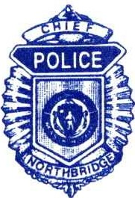
TIMOTHY LABRIE
CHIEF OF POLICE
TOWN OF NORTHBRIDGE

HIRING : POLICE/FIRE/EMS DISPATCHER

Full-Time Dispatcher needed for fast-paced combined Police, Fire & EMS communications center.

Answers emergency calls, dispatches public safety personnel, and operates computer equipment. Requires excellent communication skills and the ability to multi-task.

Preferred applicants have the APCO or equivalent 40 hour dispatcher training, CPR & First Responder Certifications, E911 and EMD. Salary $23.06 - $28.05/hr. depending on experience. FT dispatchers are union, allowed to work police details (pending physical test) and are on a 4 on 2 off schedule. Applications can be found on the town’s webpage @ www.northbridgemass.org under employment volunteer opportunities.

Send resume, application, and cover letter to: Admin Assistant/Dispatch Supervisor Lisa Gaylord @ Lgaylord@northbridgemass.org or by mail to the Northbridge Police Department, 1 Hope Street, Whitinsville, MA. 01588.

DEPARTMENT OF POLICE
1 HOPE STREET, WHITINSVILLE, MA 01588
www.northbridgepolice.com
TEL (508) 234-6211 • FAX (508) 234-9021

JOHN OUILLETTE
LIEUTENANT

