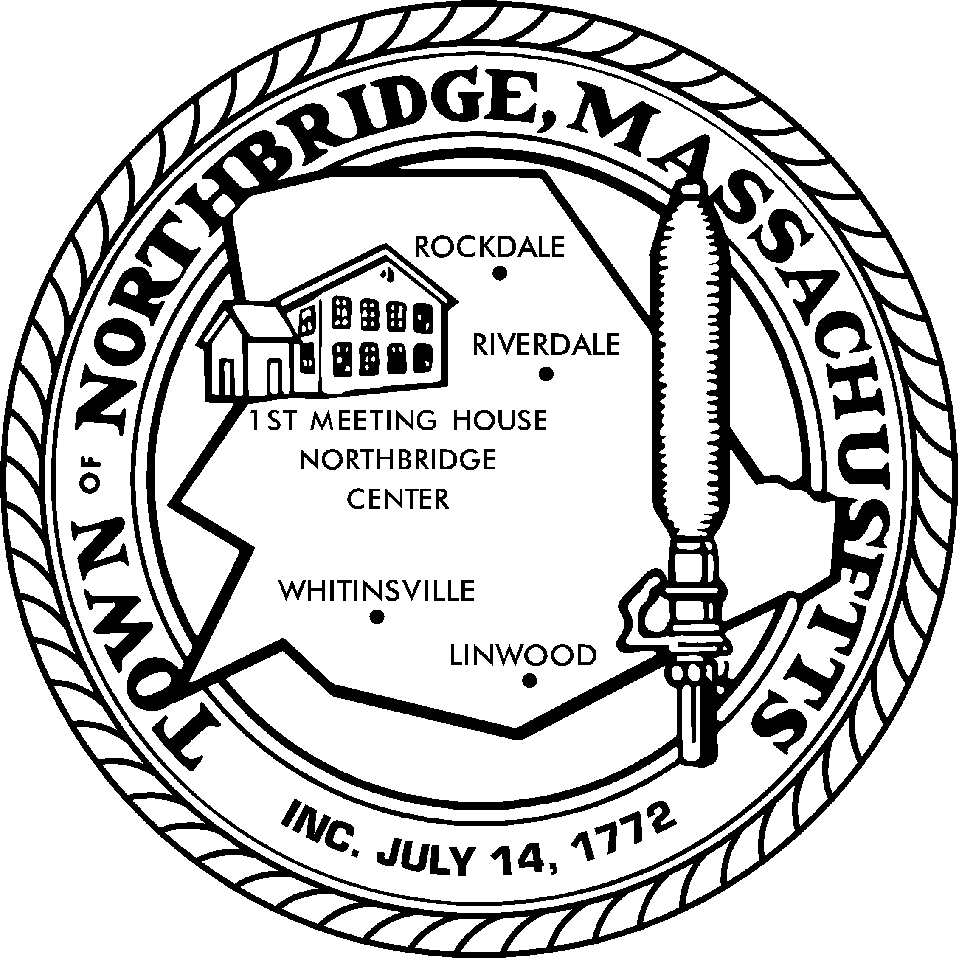
TOWN OF NORTHBRIDGE
OFFICE OF THE TOWN MANAGER
NORTHBRIDGE TOWN HALL
7 MAIN STREET
WHITINSVILLE, MASSACHUSETTS 01588
Phone: (508) 234-2095 Fax: (508) 234-7640
www.northbridgemass.org
Adam D. Gaudette
Town Manager

PRESS RELEASE

Permanent closing of Northbridge Recycling Center Location
(located behind the Main Street Fire Station Headquarters)

Posted: April 14, 2022

Effective Saturday, June 25, 2022, the Northbridge Recycling Center will no longer be operational.

Going forward residents may visit the Blackstone Valley Recycling Center located at 14 Chestnut Street, Blackstone, MA.

There is an annual $40.00 sticker fee, plus $5.00 per recycling container. The fee schedule is on their website at https://www.townofblackstone.org/blackstone-valley-regional-recycling-center.

The main reasons for the Northbridge Recycling Center closing are the following:

- The Town is in the process of constructing a new Fire Station and will be disposing of the Main Street Headquarters.

- Rising costs of operating the facility due to the commodities market.

- Difficulty staffing the facility.

- Option of zero-sort recycling offered by Trash Haulers.

- Option of visiting the Blackstone Center directly.

If you have any questions or concerns, you may contact the office of the Town Manager at (508) 234-2095.

